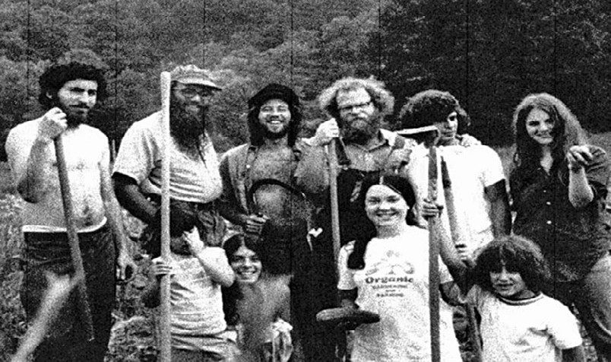
Some people arrive in a place and pass through. Others arrive and become part of the fabric of the community itself. Michael Tabor, who has farmed in Fulton County since 1973, is decidedly the latter.
If you had told the young Michael growing up in the Fort Greene housing projects of Brooklyn that he would spend more than half a century as a Pennsylvania farmer, he
The Licking Creek Bend Farm crew in 1972. Mike Tabor is pictured fourth from the left in the back row.
Probably would have laughed. The son of a photographer and social worker, raised in a kosher home where his Bessarabian grandmother believed in the evil eye and old-country Jewish healing, he seemed destined for a different path entirely.
But sometimes the seeds planted in childhood take root in unexpected soil. As a first grader at P.S. 67, Michael bought a one-cent packet of carrot seeds from the Brooklyn Botanical Garden. Each week, he tended his plot at the library’s outdoor space, watching those carrots grow. He can still taste them, he says, soil coating the sweet, crisp vegetables he pulled from the earth. Perhaps that was the moment the trajectory of his life shifted, though it would take decades for the change to become clear.
The journey from Brooklyn to Fulton County wound through some of the most turbulent years of American history. At SUNY Oneonta in the early 1960s, this city kid encountered rural America for the first time and found himself fascinated by train yard old-timers and their stories of a vanishing country. He started an underground newspaper that got him politely expelled through an accelerated graduation program. At the University of Maryland, he joined the civil rights movement, was beaten bloody doing voter registration work in North Carolina, and publicly burned his PhD papers when the American Association of University Professors refused to take a stand against segregation.
By 1970, he and his then-wife Martha were working in Washington, DC, and looking for a weekend place. They found property in Fulton County. What they did with it, though, was anything but conventional.
Inspired by the first Earth Day and a Zen Buddhist teacher who had urged Michael to explore the mystical depths of his own Jewish traditions, they wanted to do something conscientious with their land. In the summer of 1971, Arthur Waskow, his wife Irene, and their two young children rented the farm for a couple of months. That visit helped inspire the concept of what became, in 1972, what they believe was the first and only diaspora kibbutz in America. About 50 mostly young people came to learn collective farming, live off the land, and connect social justice work with Jewish renewal. When Hurricane Agnes flooded the farm later that year, the commune disbanded, but Michael and Martha stayed.
They bought sheep, goats, bees, mules, and work horses. Michael, the Jewish kid from the projects, became a midwife to lambing ewes, performing episiotomies and breech births that kept him awake through spring nights. At daybreak, he would stand at the barn doorpost, wiping blood from his hands on the wood, perhaps unconsciously echoing an ancient ritual of protection.
Animal husbandry proved economically impractical, but when neighbors Jim and Moe Crawford invited them into an emerging farm-to-city concept in 1973, Michael found his calling. He sold the animals and started truck farming, eventually establishing one of Washington DC’s earliest neighborhood markets in the Adams Morgan district.
What makes Michael more than just another farmer, though, is his philosophy. He sees the Jewish calendar through agricultural eyes, understanding that Passover marks barley harvest and lambing, that Shavuot celebrates first fruits and wheat harvest, that the ancient festivals his ancestors observed were fundamentally tied to the rhythms of planting and reaping. He has spent decades making those connections tangible, not just spiritual.
More importantly, he has dedicated his work to ensuring that healthy, pesticide-free food is accessible to everyone, not just those who can afford premium prices. When a customer once asked him to point out which produce at his market was pesticide free because she assumed she could not afford it, the question cut deep. His response has been decades of participation in subsidy programs, partnerships with nonprofits, and his own assistance programs for families in need.
Now 83, Michael continues farming with his wife Esther Siegel, who manages the farm administration. Their produce appears at community markets in Adams Morgan and at the Takoma Park Silver Spring Food Co-op during growing season. They welcome volunteers and CSA members who want affordable boxes of freshly picked pesticide free vegetables.
He has been arrested for civil rights and climate activism. He was sponsored by Catholic Relief to travel to Tanzania to teach farming methods discouraging chemical pesticides. He has maintained his Jewish practice while embracing Unitarianism, Quakerism, and Buddhism. He has raised three children and spent more than five decades proving that an absolute stranger can indeed become not just a neighbor but a pillar of a rural community.
Milton Silver, who once ran the Chambersburg Livestock Auction, understood this. When Michael and about twenty members of the kibbutz showed up at the auction one day, Milton stopped everything, pointed them out, and announced with pride that local kibbutzniks had joined them.
There was something in his voice that recognized what Michael represented: the unlikely becoming inevitable, the outsider becoming essential, the wandering finally becoming home.
Fulton County is richer for having this Brooklyn kid among us, still covered in good soil after all these years.

